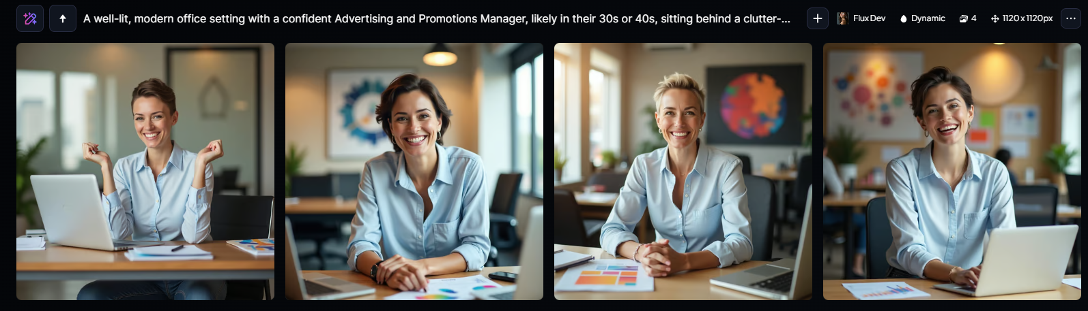

“A well-lit, modern office setting with a confident Advertising and Promotions Manager, likely in their 30s or 40s, sitting behind a clutter-free, wooden desk, with a warm, approachable smile and raised eyebrows, conveying a sense of excitement and enthusiasm, dressed in business casual attire, perhaps a light-blue or white button-down shirt, dark-washed jeans, and minimal jewelry, with a few strategically-placed, colorful marketing materials and a sleek laptop in front of them, surrounded by a blurred-out cityscape or a blurred company logo on the wall, conveying a sense of professionalism and creativity, with a subtle, natural-looking makeup and a short, stylish haircut, against a soft, creamy background that complements the subject's skin tone, with a shallow depth of field, and a slight, warm glow to emphasize the professional's friendly and approachable demeanor.”



“A busy and confident Advertising and Promotions Manager sits at a cluttered desk in a modern office, surrounded by papers, pens, and a computer with multiple screens displaying various marketing analytics and campaign metrics, with a notepad and coffee cup to the side, wearing a professional attire such as a white blouse with a subtle pattern and a tailored black blazer, with short, styled brown hair and a friendly smile, focusing intently on a creative concept sketch on a large piece of paper in front of them, with a few colleagues blurred in the background engaged in discussions, set against a muted color palette with neutral tones and hints of bright pastels, evoking a sense of dynamic energy and creative problem-solving.”

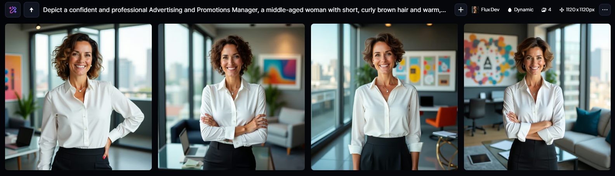

“Depict a confident and professional Advertising and Promotions Manager, a middle-aged woman with short, curly brown hair and warm, golden skin, wearing a crisp white business shirt with a modern, slim-fit design, paired with a tailored black pencil skirt, and standing in a sleek, contemporary office setting with a cityscape view through the floor-to-ceiling windows behind her, surrounded by creative materials and marketing props such as colorful posters, laptops, and a glass coffee table, with a friendly and approachable smile on her face, showing a few wrinkles around her bright, expressive brown eyes, and a silver necklace with a small, elegant pendant, exuding an air of competence and creativity, with the overall mood of the image being vibrant, dynamic, and entrepreneurial, conveying a sense of innovation and success in the advertising industry.”